* Execute eCasesRetraction.ps1 (skip this if it is the first time of installation).Retract existing WSPs if they exist:
* Treasury.ECM.eCase.SusDeb.DOI.Common
* Treasury.ECM.eCase.SusDeb.DOI.Extensions
* Treasury.ECM.eCase.SusDeb.DOI.Logging
* Treasury.ECM.eCase.SusDeb.DOI.Search
* Treasury.ECM.eCase.SusDeb.DOI.Site
* Treasury.ECM.eCase.SusDeb.DOI.Web
* Update eCaseMembers.txt and eCaseOwners.txt files as appropriate. These files should contain user login names, including domain, that are to be added to the associated Site Collection groups. One login per line. Ensure there are no empty/blank lines. Ex: **TREASURY\tstspadmin**
* Create a content database name it WSS_Content_Apps_eCase_DOI (if it doesn’t exit) by running this powershell (Recommend one database per SusDeb Site Collection)

New-SPContentdatabase WSS_Content_Apps_eCase_DOI –webapplication https://apps.testecm.gov

* Configure the WSS_Content_Apps_eCase_DOI Database.
* Open SQL Server Studio Management and connect to a SQL Server instance
* Update the SusDebDB.sql USE statement to reference the correct database
* Execute the script
* Create a new SQL Authenticated user (e.g. eCaseUser)
* Grant new user db_datareader and db_datawriter permissions on the new database
* Grant the new user EXECUTE permissions on the stored procedures as shown in image. eCaseManagementPermissions.sql script can be modified (use the same user created above) and used to accomplish this. *Note: Not all stored procedures may be visible in the image below. The purpose of the image is to show how to verify the GRANT was performed.

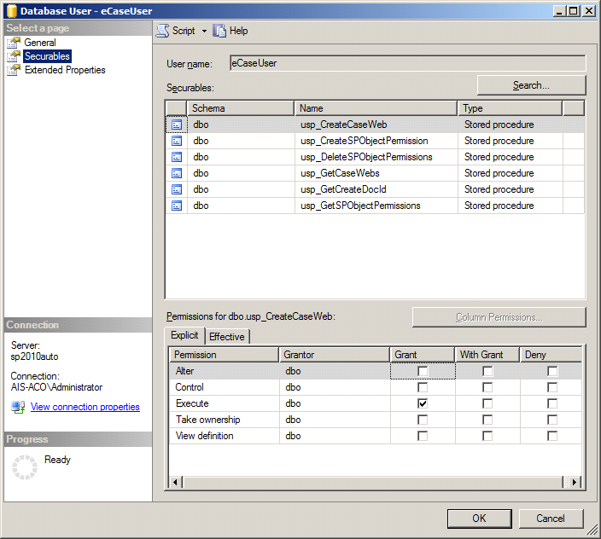

* Execute eCasesDeployment.ps1. This script will add and deploy **all** WSPs in the folder in which it exists.
* Verify WSPs successfully deployed by navigating to Manage Farm Solutions in Central Admin
* Verify Diagnostic Area and Categories are present. If not, perform the following:
* Navigate to “Manage Farm Features”
* Deactivate Treasury.ECM Logging Configurator - DOI
* Recycle the Central Admin app pool
* Verify the Diagnostic Area/Categories below are removed
* Reactivate Treasury.ECM.eCase Logging Configurator - DOI
* Recycle the Central Admin app pool
* Verify Diagnostic Area and Categories are correct. If not, contact developer.

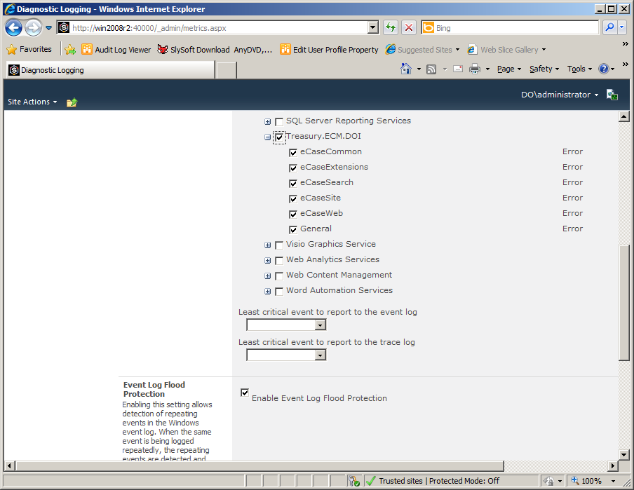

* Configure Diagnostic Area/Categories Event and Trace levels as desired. Note, custom code in the eCase Management system will not attempt to write to the Event Log, regardless of configuration.
* (Skip this) Import the Law Issue List managed metadata. Using the GUI for Term Store Management, import the LIL.csv file. Please verify the term set was created. (skip this)



* Execute eCasesSiteProvisioner.ps1. This script will delete the existing site if present, and create a new site. You can create the Site Collection using the Central Admin UI if preferred; the Site Collection Template will appear under the Treasury templates tab/group.  
  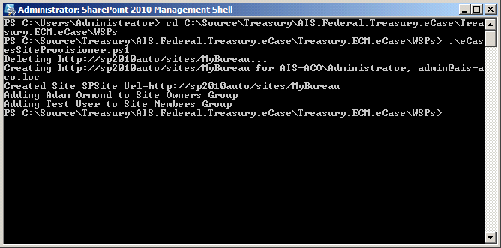
* Verify site opens correctly in IE.  
  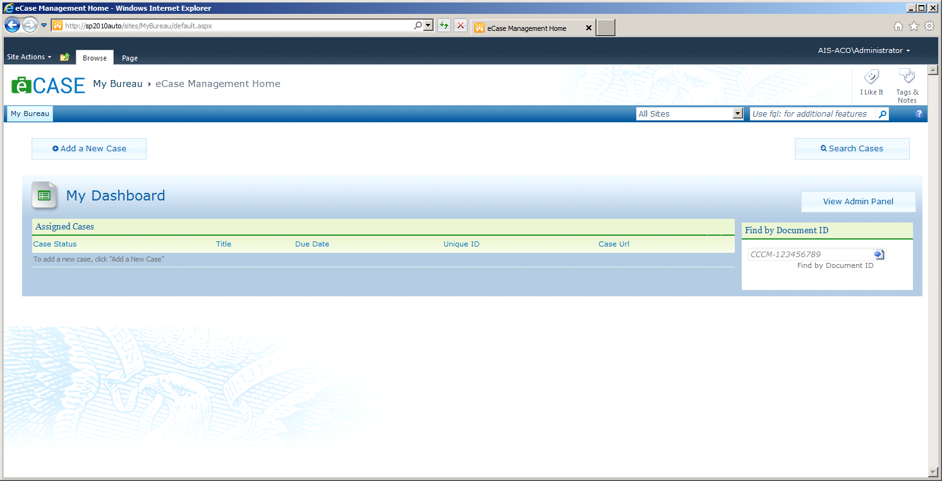

Stop here and skip the rest.

* Execute the eCaseFastConfig.ps1 script to configure the Crawled Properties, Managed Properties, Managed Property Mappings, Full-Text Index, and Rank Profile used by the eCase FAST Search Center.
* Navigate to Search Results page by executing a search in the SmallSearchInputBox control. If the View control (directly beneath the search input box) does not function (it likely doesn’t, not sure why), perform the following:
* Click the Publish Tab in the Ribbon
* Click “Unpublish”
* Execute another search and verify that the View control will now alter the display

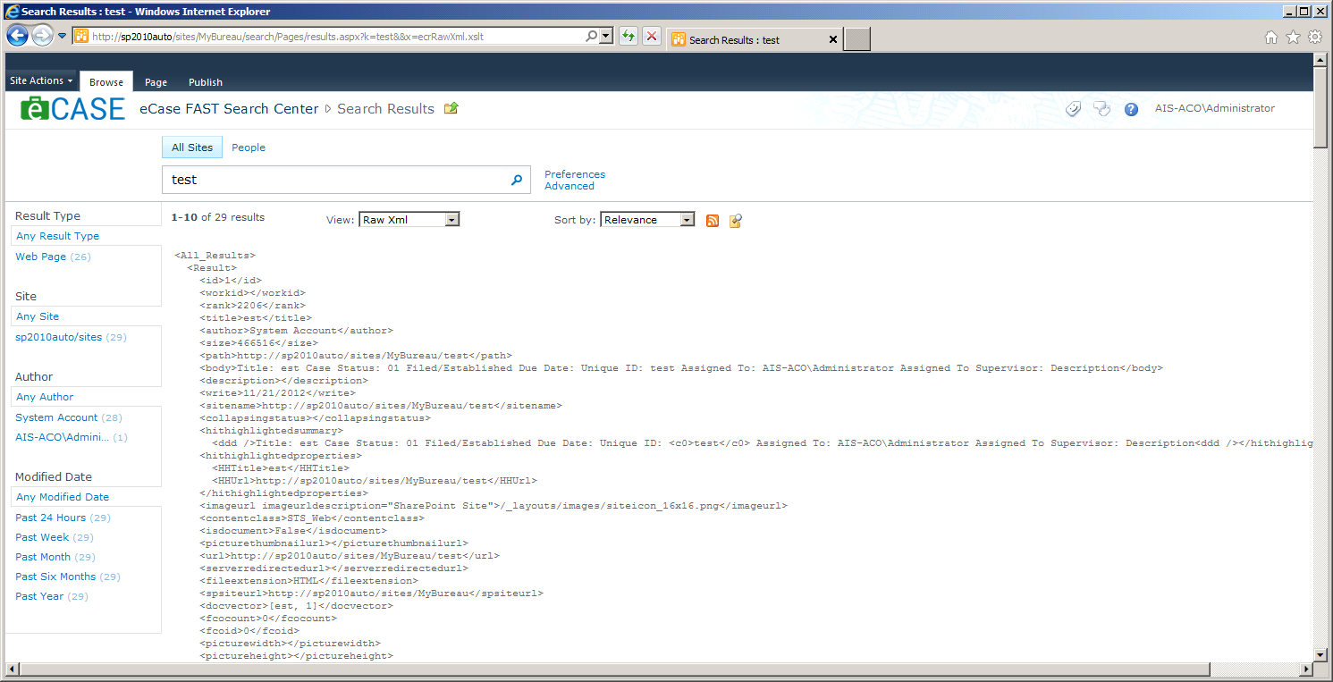

* In the Search Results page, edit the eCase Core Results web part’s Fetched Properties property, within the Display section, by replacing the existing content with that found in eCaseSearchFetchedProperties.xml
* In the Search Results page, edit the Refinement Panel web part’s Filter Category Definition property, within the Refinement section, by replacing the existing content with that found in eCaseSearchFilterDefs.xml.
* Update ecasedb Property Bag setting on Site Collection in Central Admin to point at database. Update ecasedocprefix if required. At the Web Application level, add a property SiteCollectionSearchList and include the path to the site collection that was just created.

